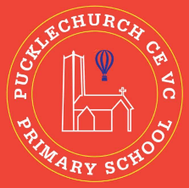
Theme map: Year 2 Term 1
Social, Moral, Spiritual and Cultural (SMSC) Links
- How do I become a great friend?
- Why do I like what I like?
- How do I face new challenges?
- What can I do to set a positive example to others?
Friendship

Key Text – The Tin Forest by Helen Ward
Maths – Place Value, Addition and Subtraction
Science: - Working scientifically
RE: - Why and how do people celebrate significant events? Judaism
History – Great Fire of London
Music – Identify minims and crotchets
PE –Real PE Footwork real dance/
Art – Leonardo Da Vinci and Carbon paper
Computing – recognise the uses and features and uses of it
PSHE – Being me in my world
Outdoor Learning
- Using different art mediums
- Sing natural objects to create a forest.
- Rock Scavengers
- Build team work and co-operation


