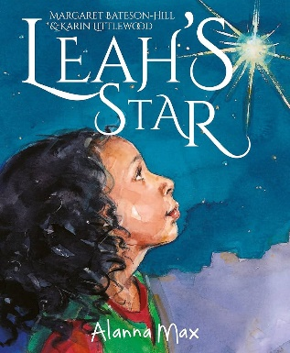
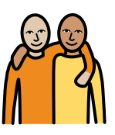
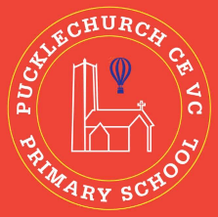
Theme map: Year 1 Term 2
Social, Moral, Spiritual and Cultural (SMSC) Links
- How did people show generosity?
- How am I the same as others?
- How am I different to others?
- How do Christians worship?
Outdoor Learning
- Use sticks to create a stick family
- Using natural materials to make a maze
- Use resources to build bridges
- Identify if objects will float or sink
Generosity
Key Text – Leah’s star
Maths – Addition, Subtraction, shape
Science: - Animals
RE: - Christianity
Geograohy – The UK and Pucklechurch
Music – Nativity songs
PE – Dance and Real PE
DT – Sliders and Levers
Computing – Computer technologies
PSHE – Celebrating difference

