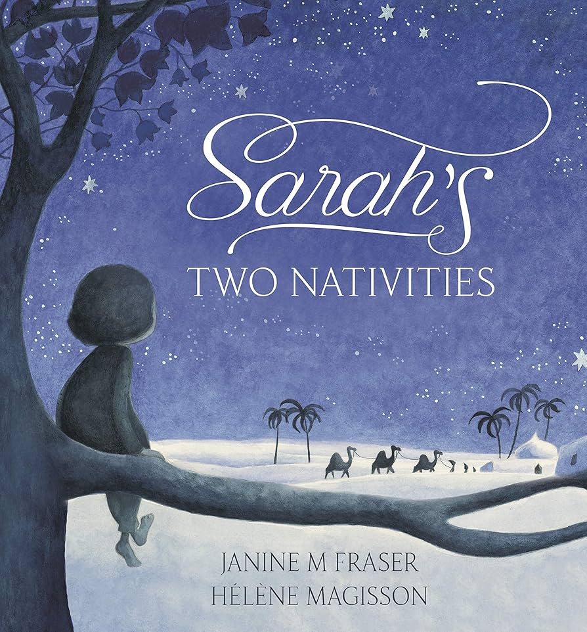
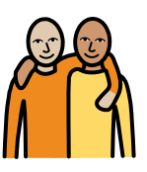
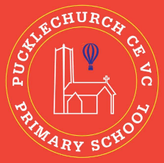
Theme map: Year 2 Term 2
Social, Moral, Spiritual and Cultural (SMSC) Links
- How did people show generosity?
- How am I the same as others?
- How am I different to others?
- How do Christians worship?

Generosity

Outdoor Learning
- Use sticks to create a stick family
- Using natural materials to make a maze
- Use resources to build bridges
- Identify if objects will float or sink
Key Text – Sarah’s Two Nativities
Maths – Addition and Subtraction, Shape
Science: - Everyday Materials
RE – Christianity/ The Nativity Story
Geography – The United Kingdom
Music – Recorders/ Nativity songs
PE – Real PE (jumping)
DT – Freestanding Structures
Computing – Digital Photography
PSHE – Celebrating difference

