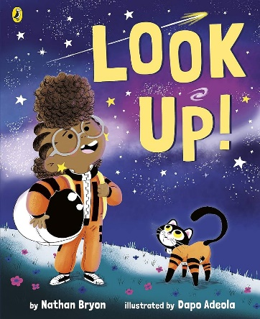

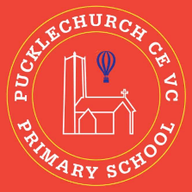
Theme map: Year 1 Term 3
Outdoor Learning
- Use natural resources to create birds
- Make observations on what winter looks like.
- Create a boat using different materials.
- Identify if objects will float or sink
Social, Moral, Spiritual and Cultural (SMSC) Links
- How did people show compassion?
- What are my dreams for this year?
- What are my dreams for the future?
- How do Muslims worship?
Compassion
Key Text – Look up!
Maths – Place Value
Science: - Everyday materials
RE: - Islam
History – Neil Armstrong
Music – In the groove
PE – Dance and Real PE
Art– Bird sculptures
Computing – programming
PSHE – Dreams and goals

