
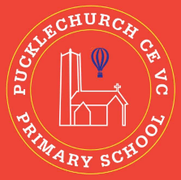
Theme map: Year 2 Term 3
Compassion
Key Text – Lost
Maths – Addition and Subtraction, Shape, Money, Multiplication and Division
Science: - Living and Non-Living things
RE – Holy books
History – Christopher Columbus
Music – Learn/ play to the son ‘I wanna play in a band’.
PE – Dance
Art – Vincent Van Gogh
Computing – Robot algorithms
PSHE – Dreams and goals

Outdoor Learning
- Use natural resources to create birds
- Make observations on what winter looks like
- Create a boat using different materials.

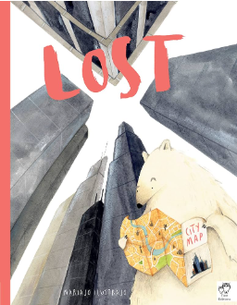
Social, Moral, Spiritual and Cultural (SMSC) Links
- How did people show compassion?
- How can I help others?
- What is compassionate and what is not?
- How do religious people use holy books?

