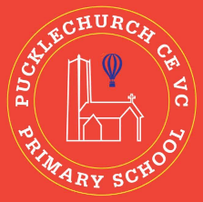
Theme map: Year 2 Term 4
Forgiveness
Key Text – Somebody Swallowed Stanley
Maths – Money, Multiplication and Division, Length and Capacity
Science: - Everyday Materials.
Animals, including humans.
RE – What do Christians believe God is like?
Geography – UK, Seas and Oceans, American continent
Music – Learn/ play to the song ‘Zoo Time’.
PE – Using racquets (target games)
DT – Compare data
Computing – Robot algorithms
PSHE – Healthy Me

Outdoor Learning
- Use natural resources to create forgiveness wands.
- Make observations on what everyday materials we can find.
- Practise throwing and hitting a ball.

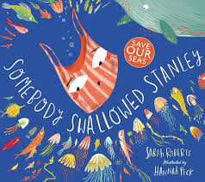

Social, Moral, Spiritual and Cultural (SMSC) Links
- How did people show forgiveness?
- How can I help others?
- Should I always forgive?
- What do religious people believe about God?

