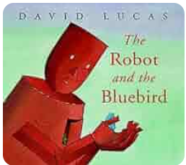

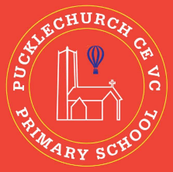
Theme map: Year 1 Term 5
Outdoor Learning
- Identify the parts of a plant around the school grounds.
- Outdoor art inspired by the works of Paul Klee.
- Outdoor maths exploring fractions.
Social, Moral, Spiritual and Cultural (SMSC) Links
- How do I respect the relationships around me?
- How is respect shown in Islam?
- How do I respect the plant and living things around me?
Respect
Key Text – The Robot and The Blue bird
Maths – Fractions
Science: - Plants
RE: - Islam
History – Rosa Parks
Music – Your imagination
PE – Throwing and catiching/ Real PE
Art– Water colours
Computing – Using the keyboard
PSHE – Relationships

