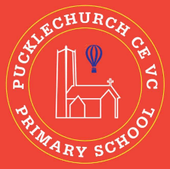
Theme map: Year 2 Term 5
Respect
Key Text – The Lighthouse Keeper’s lunch
Maths – Fractions and Time
Science: - Plants
RE – Compare Christianity and Judaism
History – Pucklechurch and St Thomas Beckett.
Music – The Friendship Song.
PE – Catching and Throwing / Real PE.
Art – Architecture and Hundertwasser
Computing – Digital music
PSHE – Relationships

Outdoor Learning
- Identify plants around the school.
- Use resources to create your own architecture.
- Use natural resources to explore fractions.

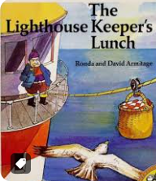

Social, Moral, Spiritual and Cultural (SMSC) Links
- How do you show respect to plants?
- How can I respect others?
- How did St Thomas Beckett show Respect?
- How do I respect my relationships?

