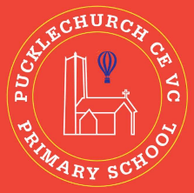
Theme map: Year 2 Term 6
Courage
Key Text – Lila and the Secret of Rain
Maths – Measurement and Statistics
Science: - Animals, including humans
RE – Understanding Christianity, Bible Stories
Geography – Human and Physical features of Kenya
Music – Reflect, rewind and replay
PE – Athletics / Real PE
DT – Food
Computing – Programming
PSHE – Changing me

Outdoor Learning
- Identify animals around the school.
- Identify growing fruits and vegetables
- Use natural resources to represent data

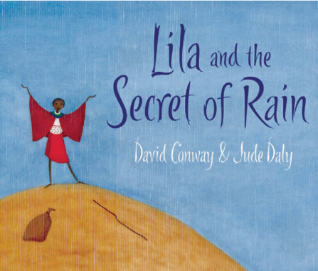

Social, Moral, Spiritual and Cultural (SMSC) Links
- Do all animals show courage?
- When can I show courage?
- What can I do to show courage?
- How can we show respect to those living in Kenya?

