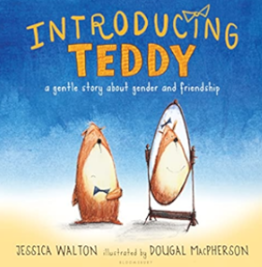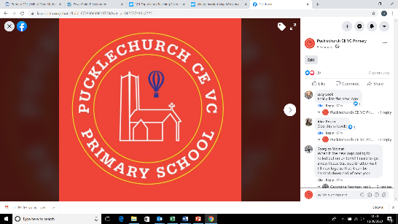Theme map: Seacole Term 1

**Key Text** – Introducing Teddy

**Maths** – Matching, sorting and comparing amounts, measure and patterns and numbers 1,2 ,3

**PSHE** – Being Me in my World

**Literacy**- phase 2 phonics, writing initial sounds, name writing

**Understanding the world**- Learning about Mary Seacole, learning about Pucklechurch and our school, talking about past and present, identifying signs of autumn

**Expressive art and design**- creating Kandinsky style pictures using lines and circles and colour mixing

Social, Moral, Spiritual and Cultural (SMSC) Links

* How did Mary Seacole show friendship?
* How do we show friendship?
* Who shows us friendship?

Outdoor Learning

* Finding different materials and making our own muddy recipes
* Mark making using different materials
* Bug hunting

Friendship

How can we shows friendship?