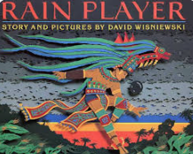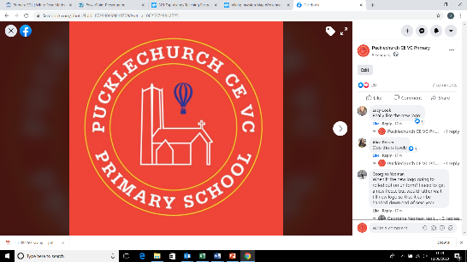Theme map: Year 3 Term 1

Key Text – Rain Player

Maths – Shape, Place Value, Addition, Subtraction

Science: - Plants

RE: - Religious festivals - Diwali

History – The Maya Civilization (Legacy)

Music – Let your Spirit fly (R and B genre)

Spanish –Greetings

PE – Invasion games (football); Real PE

Art – Working with Shape and Colour (collage and stencil printing)

Computing – Computer systems and networks

PSHE – Being Me in my World

Social, Moral, Spiritual and Cultural (SMSC) Links

* How did the Maya Civilization show friendship?
* How does it feel to be me?
* How do Hindus celebrate Diwali?
* Are all plants beautiful?

Outdoor Learning

* Exploring parts of plants (science)
* Using natural materials to mark make (Art)
* Using sunlight to mark time( history)

Friendship

What Legacy did the Maya Civilization leave?