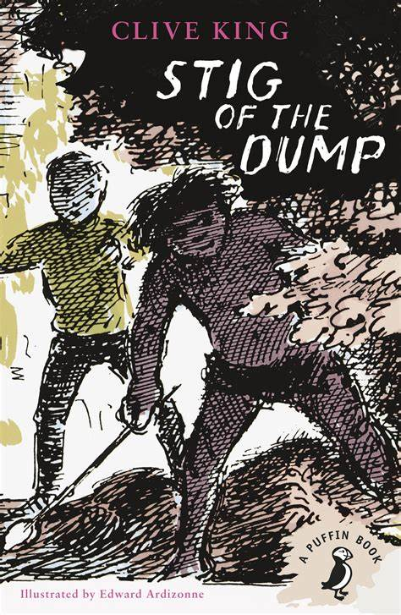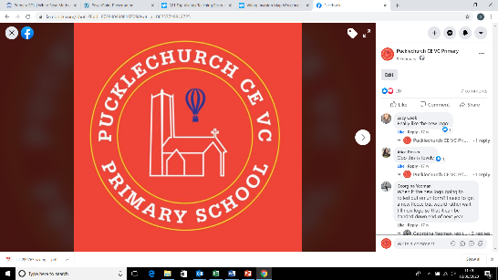Theme map: Year 4 Term 1

Social, Moral, Spiritual and Cultural (SMSC) Links

* Why is friendship so important?
* How does it feel to be me?
* What impact did Brunel have on the world?
* How do Christians follow the Bibles teachings?

Outdoor Learning

* Exploring different states of matter in nature (science)
* Observational drawing (Art)
* Using natural resources to recreate Brunel’s designs (history)

Friendship

How does Stig of the Dump show the importance of friendship?

Key Text – Stig of the Dump (Friendship)

Maths – Area, Place Value, Addition, Subtraction

Science: - Solids, Liquids and Gases

RE: - Exploring the Bible

History – The works of Brunel

Music – Musical Vocabulary and Notation

Spanish –The Seasons

PE – Invasion games (Netball) Real PE

Art – Shaun Tan – Illustrations

Computing – Data

PSHE – Being Me in my World