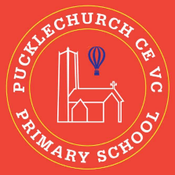
Theme map: Year 5 Term 5
Key Text – Clockwork (Phillip Pullman)
Maths – Shape, Position and Direction
Science – Changes in Properties of Material
RE – People of God
History – Who reigned during the Tudor era?
Music – The Fresh Prince
Spanish – Weather
PE – Real PE
Art – Set Design for Theatre
Computing – Vector Drawings
PSHE – Relationships

Social, Moral, Spiritual and Cultural (SMSC) Links
- Investigating how to be a ‘Person of God’
- Explore how respect is a part of daily life
- How managing relationships involves managing mutual respect
- Find evidence of respect throughout History and the impact this had on the present

Outdoor Learning
- Test materials (Science)
- Use the principles of vector drawing (Computing)
- Design inspired by nature (Art)
- Create the perfect ‘Person of God’ (R.E)
- Weekly outdoor learning tasks covering values and skills from the curriculum
Respect
Designing the Past


Fostering mutual resoe
