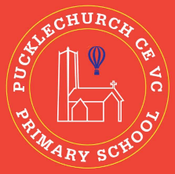
Theme map: Year 6 Term 3
Social, Moral, Spiritual and Cultural (SMSC) Links
- What are your goals for the year?
- How should people live their best lives?
- What makes the world a better place?
Compassion
Key Text – Escape from Pompeii
Maths – Area and perimeter, algebra
Science: - Light
RE: - What matters most to Humanist and Christians?
History – Ancient Greece
Music – Classroom Jazz 2
Spanish – Clothes
PE –Real PE and Gymnastics
Art – Shadow puppets
Computing – Programming
PSHE – Dreams and Goals

Outdoor Learning
- Shadow art
- Light investigation
- Outdoor programming


